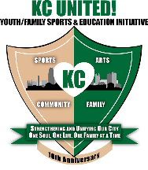

KC United! Youth Football & Cheer

Association Name:

**IMAGE RELEASE FORM ‐ MINOR**

In consideration of (insert minors name) , my minor child/ward being allowed to participate in any way in/with the organizations named above, related events and activities, I being legally authorized, do hereby my signature below agree that the organization(s) named above have the unrestricted and exclusive right and permission, free from approval or review, to copyright and use in all media now or hereafter known, including but not limited to, pictures and videos of my child/ward which he/she may be included intact or in part for promotion or other commercial use.

I have read and fully understand and agree,

Print Name

Signature Date

***Note: This form as with any and all forms used should be reviewed by your local council for compliance with any state or local statutes. This form should be kept on file for a minimum of 7 years, longer in the event of an injury. Please confer with your local attorney for advice as to the appropriate maintenance and storage term for this and all such forms.***